**NAME – ANIKET SHARMA**

**ROLL NO – 102203017**

**GROUP – 3COE-2**

**LAB ASSIGNMENT 1 (UCS534 – Cyber and Network Security)**

**Q1. Aim- To find out the IP Address, DNS IP address, Gateway IP address assigned to our computer**

**OUTPUT –**

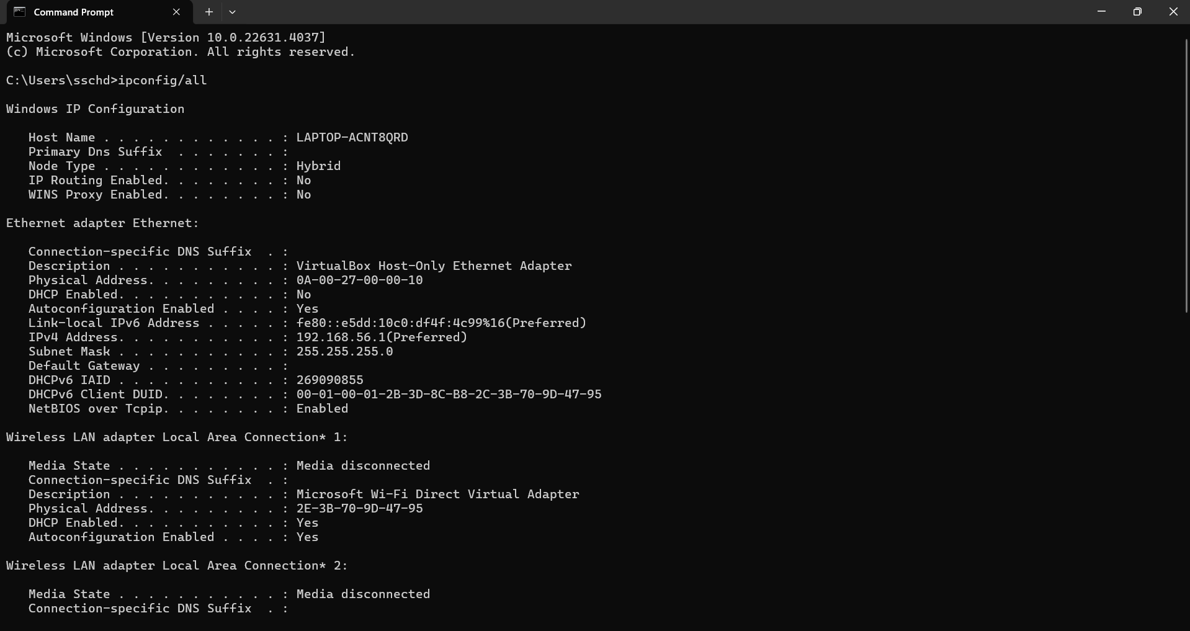

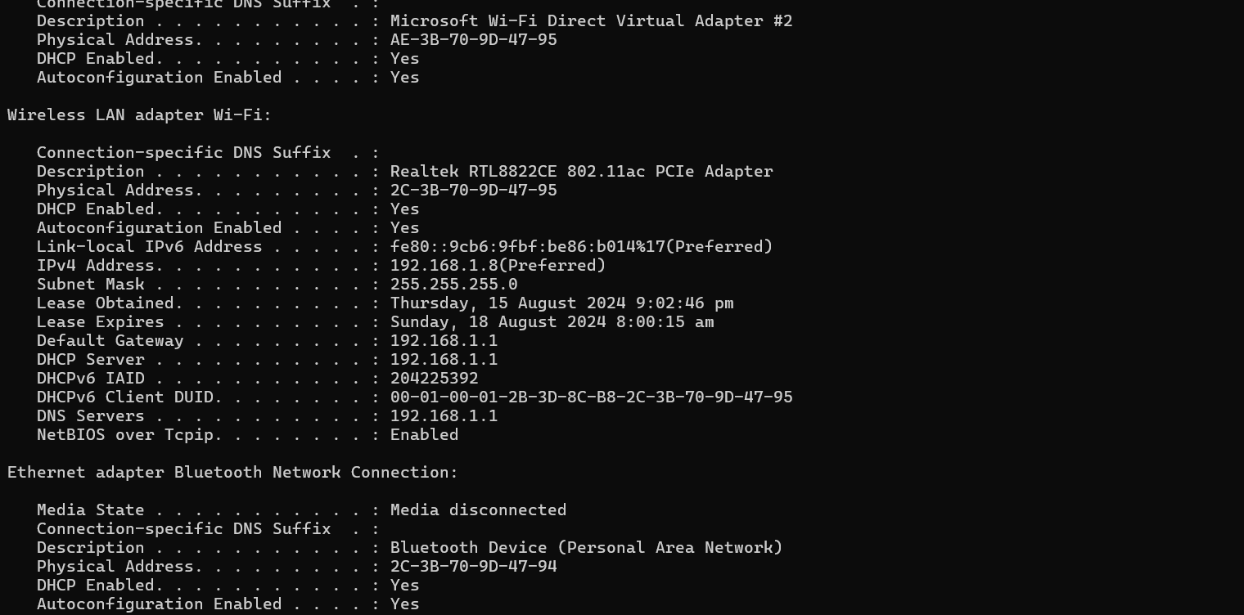

**Q2. Aim- To check different interfaces connected to the network**

**OUTPUT-**

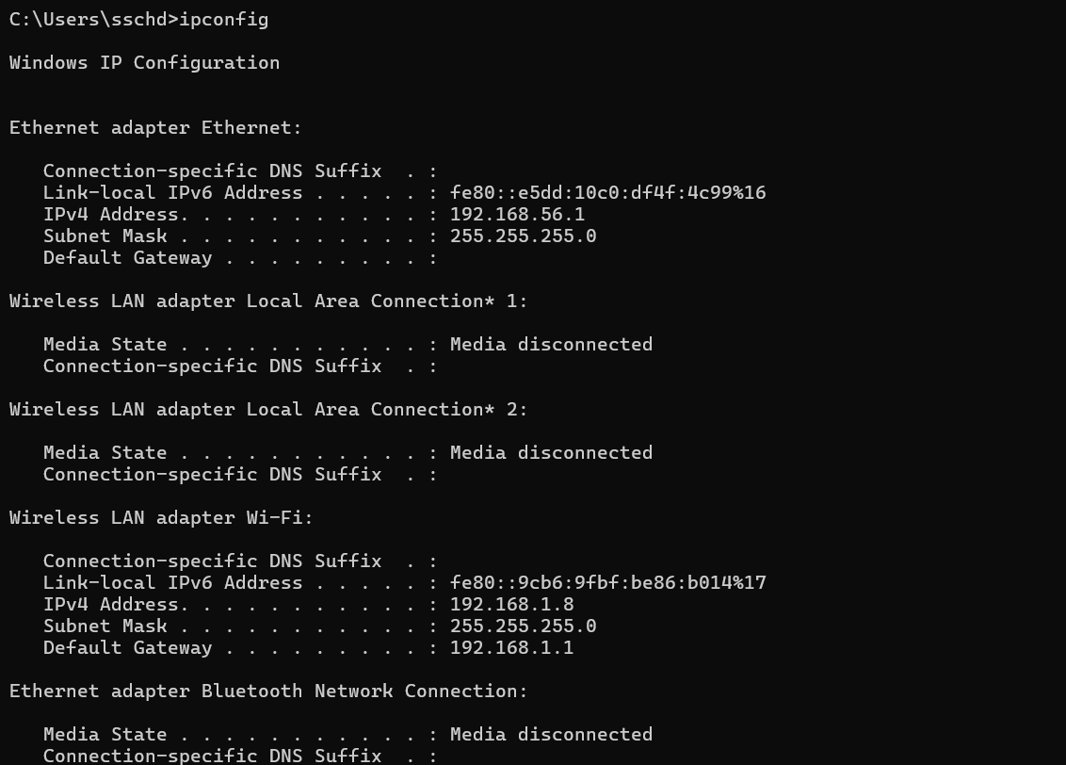

**Q3. Aim – To Alter the status of any interface**

**• Set it to Offline mode**

**• Set it again to Online mode**

**OUTPUT – 1. (Set it to offline mode)**

**2. (Set it to Online Mode)**

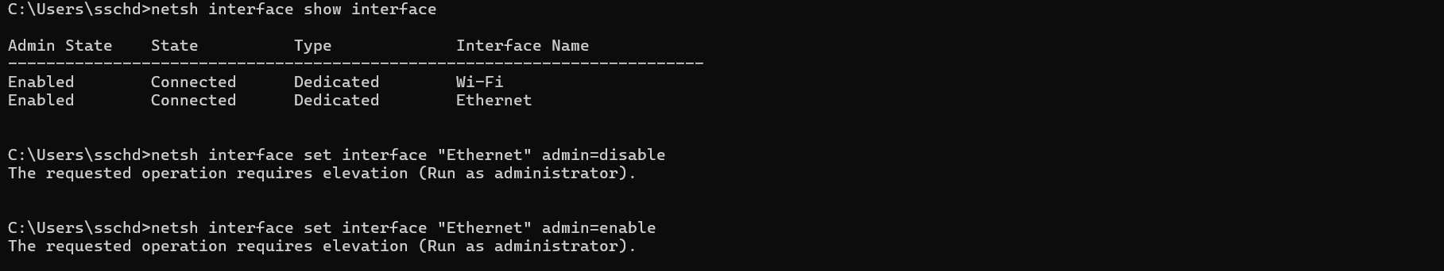

**Q4. Aim- To Change the MTU size of a packet**

**OUTPUT-**

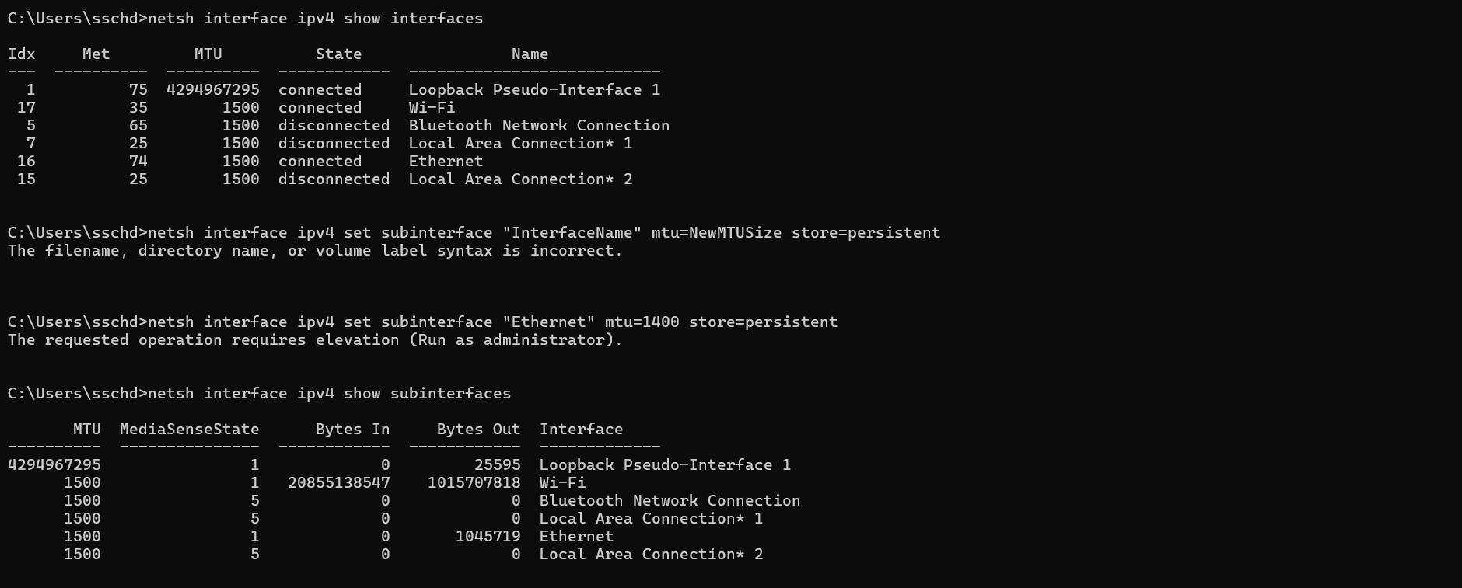

**Q5. Aim- To Find the subnet mask**

**OUTPUT-**

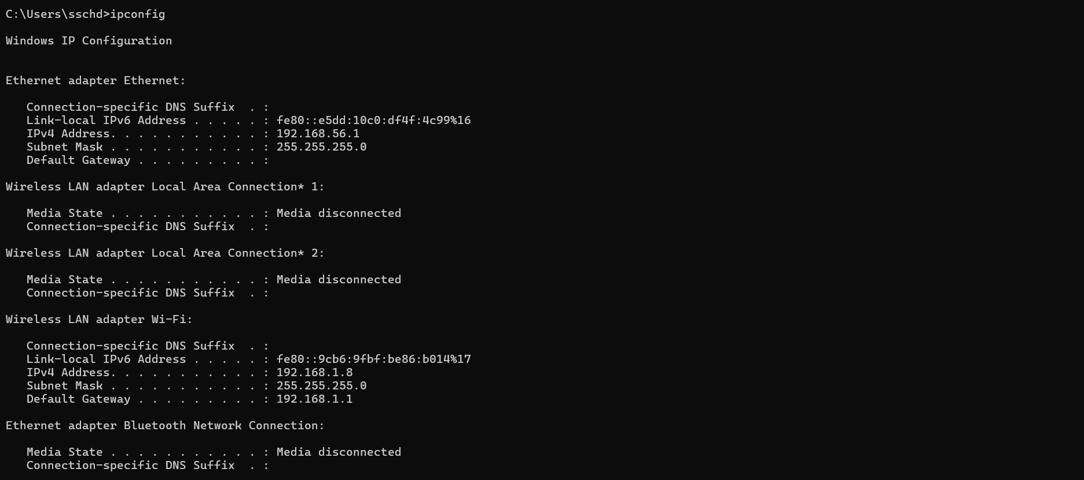

**Q6. Aim- To Calculate number of host ids in your subnet**

**OUTPUT-**

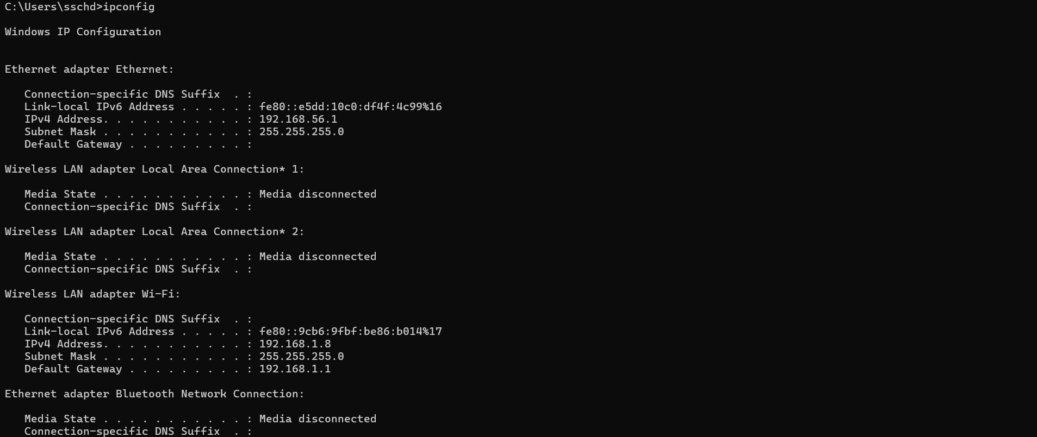

**Q7. Aim- To Find the network and broadcast address of the network you are connected to.**

**OUTPUT-**



**Q8. Aim – To a) Ping the DNS server and check the response.**

**b) Ping 8 echo requests with each packet of size 50 to any domain name/IP address and check the response.**

**c) Ping 8 echo requests with each packet of size 100000 to any domain name/IP address and check the response.**

**OUTPUT- (a)**

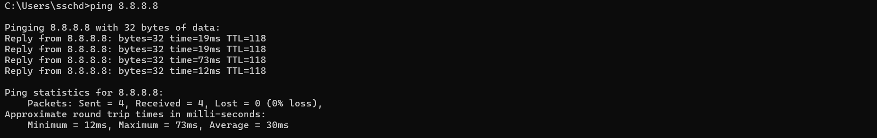

**(b) –**

**OUTPUT -**

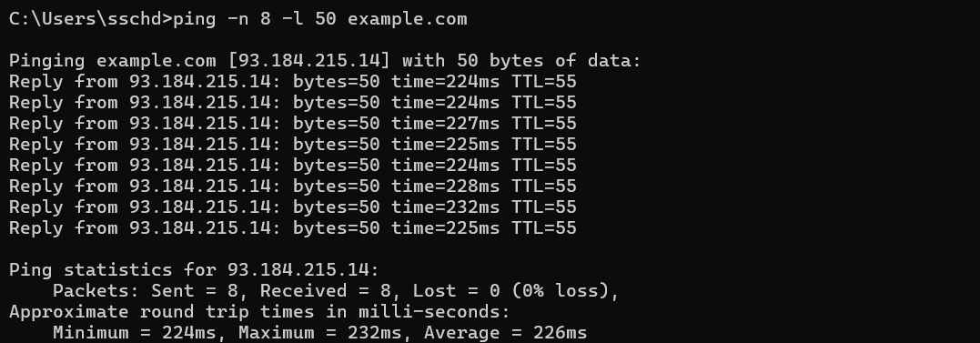

**Q9. Aim- To Find the MAC address of your device. Retrieve both the Manufacturer Id (Manufacturer as well) and the device ID.**

**OUPUT –**

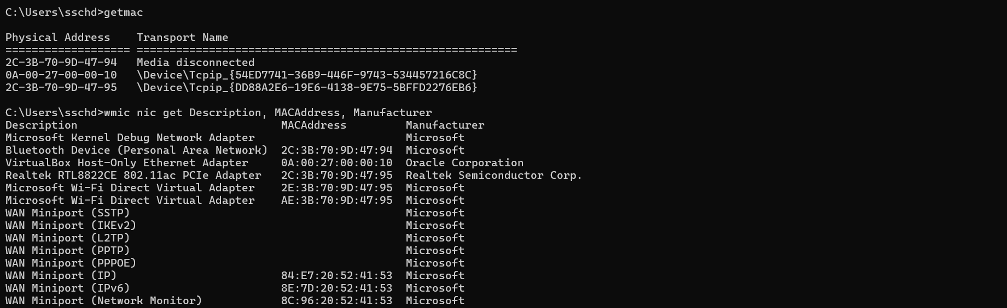

**Q10. Aim- To Find what is the Private and Public IP address assigned for your current connection.**

**OUTPUT –**

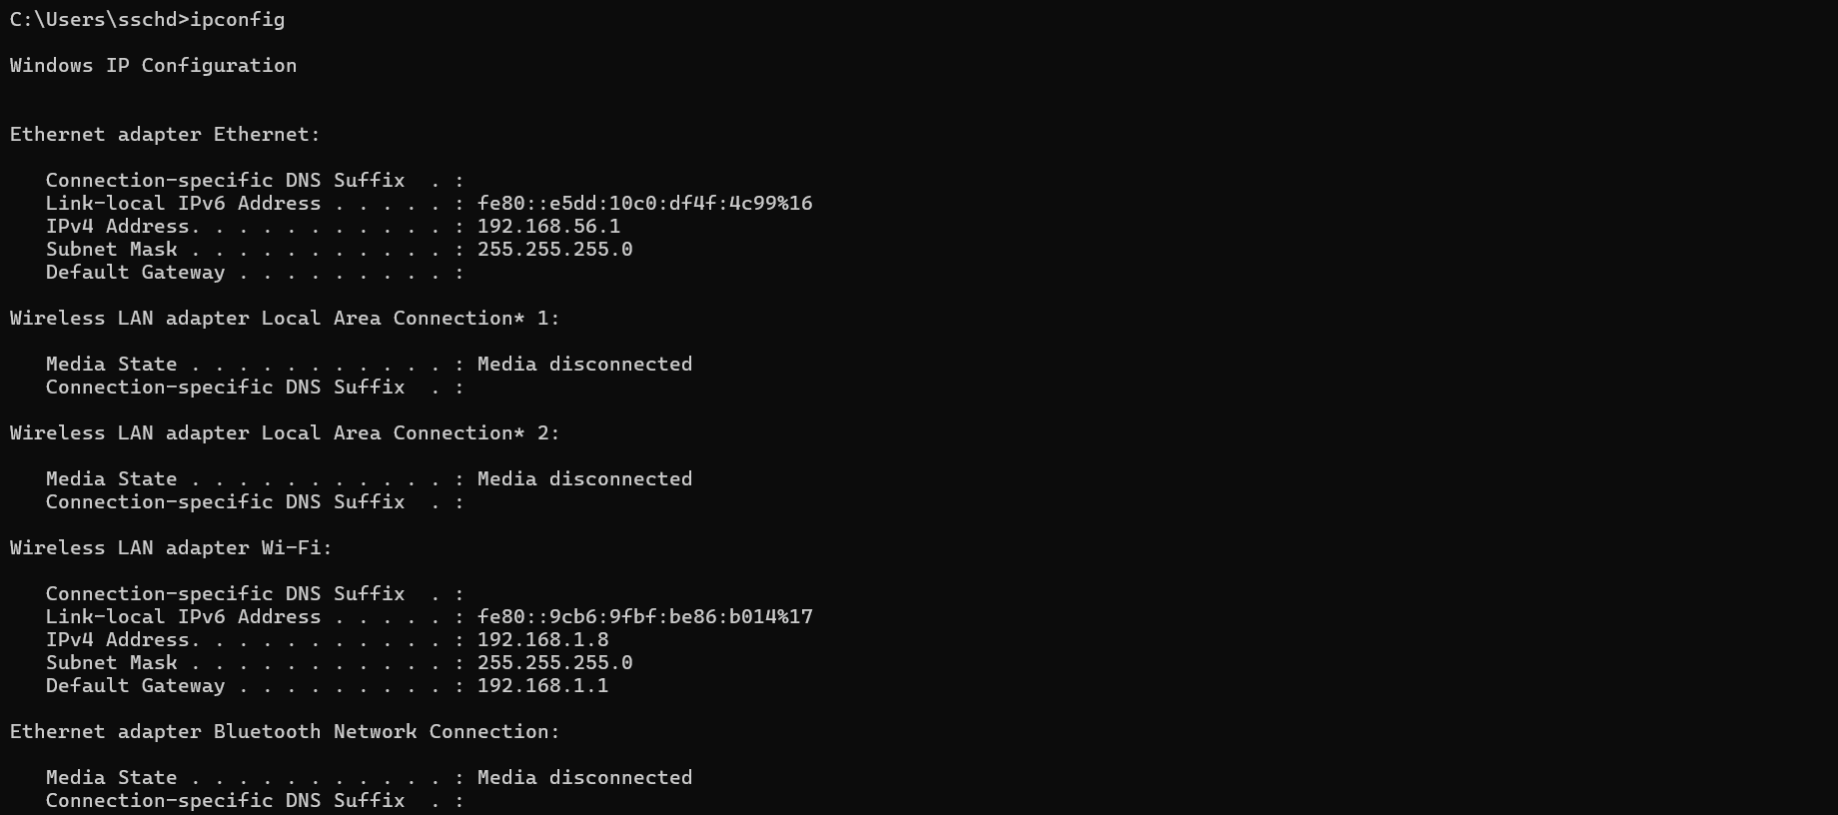

**Q11. Aim- How can you redirect the traffic through a particular gateway**

**OUTPUT –**

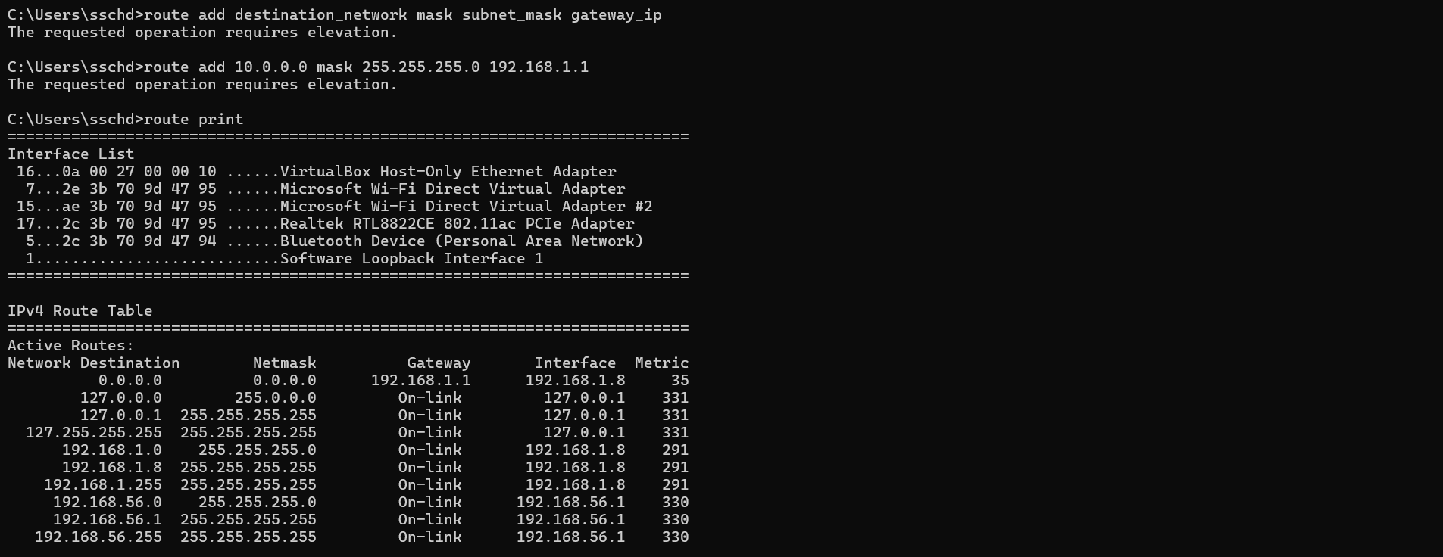

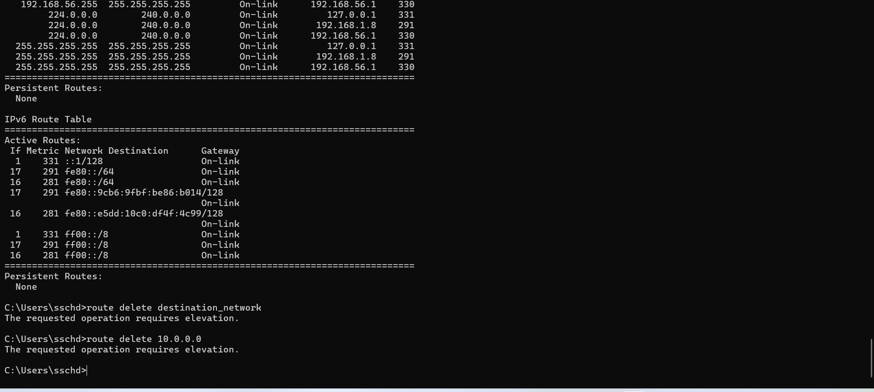

**Q12. Aim- To Look for the address of the default gateway.**

**OUTPUT –**

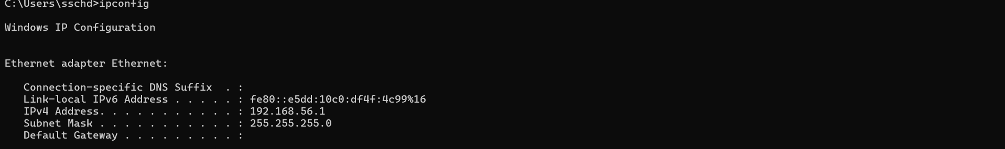

**Q13. Aim- To Find the DHCP Server IP address (if enabled)**

**OUTPUT –**





**Q14. Aim – To Count number of hosts travelled by packet to reach the destination organization. What is the IP address of second last host.**

**OUTPUT –**

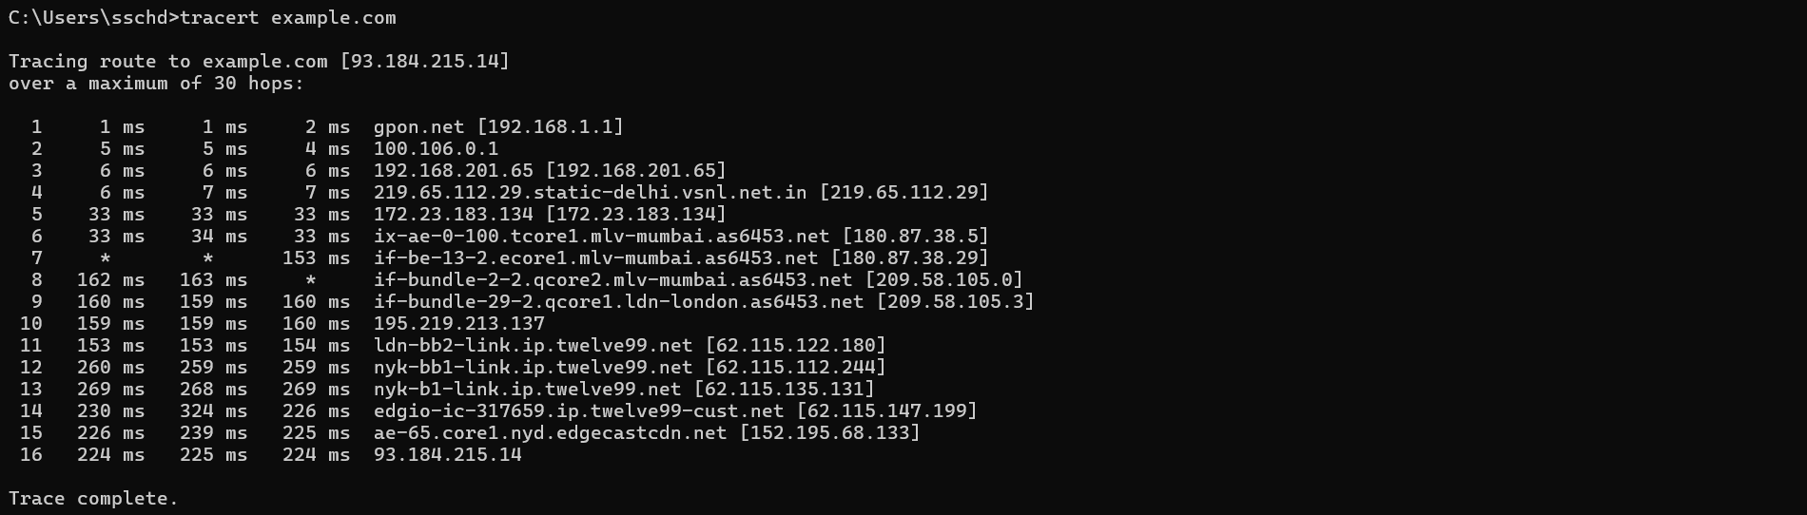

**Q15. Aim- To Generate a report of mtr command result (Use Ubuntu for this command) (Try to set different attributes for the same e.g. hops, number of pings etc.)**

**OUTPUT –**